**Front End Running Requirements/Documentation**

**Libby-**

* Design draft document: <https://github.com/AnthonyLaneJr/TeamWhatever/blob/main/DraftDesign.pdf>
* 
  + Designed the first section of the website, changes have been made since, and Riley’s section of it is more accurate

**Riley-**

## The first thing on the homepage:



## Scroll down to make a selection:

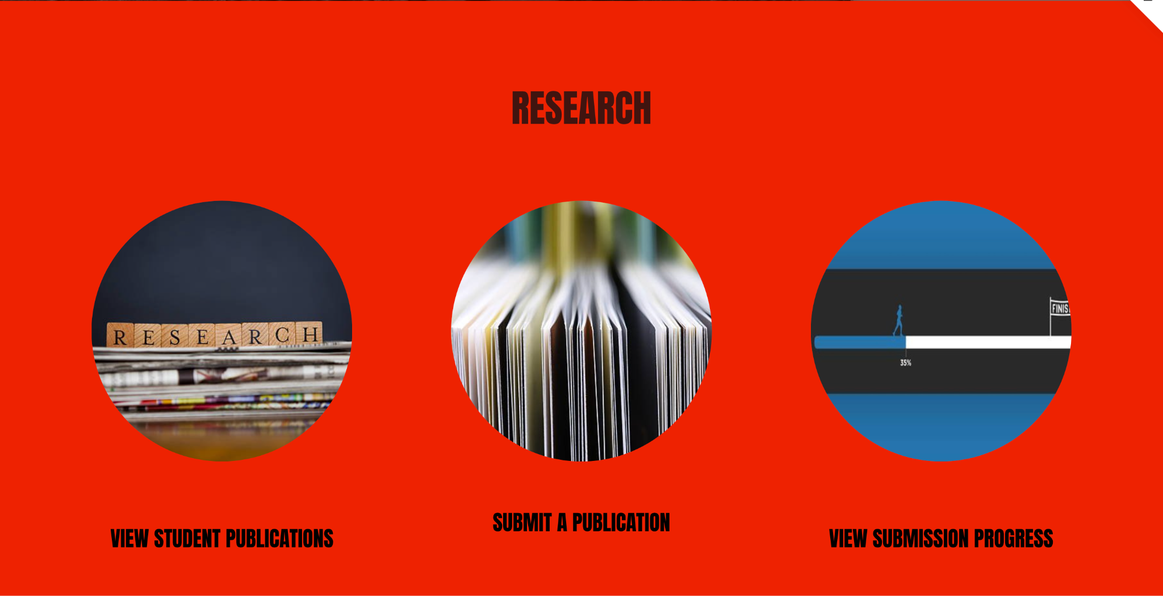

## Scroll down some more for calendar/news/upcoming event:

## The footer:



## The header banner:

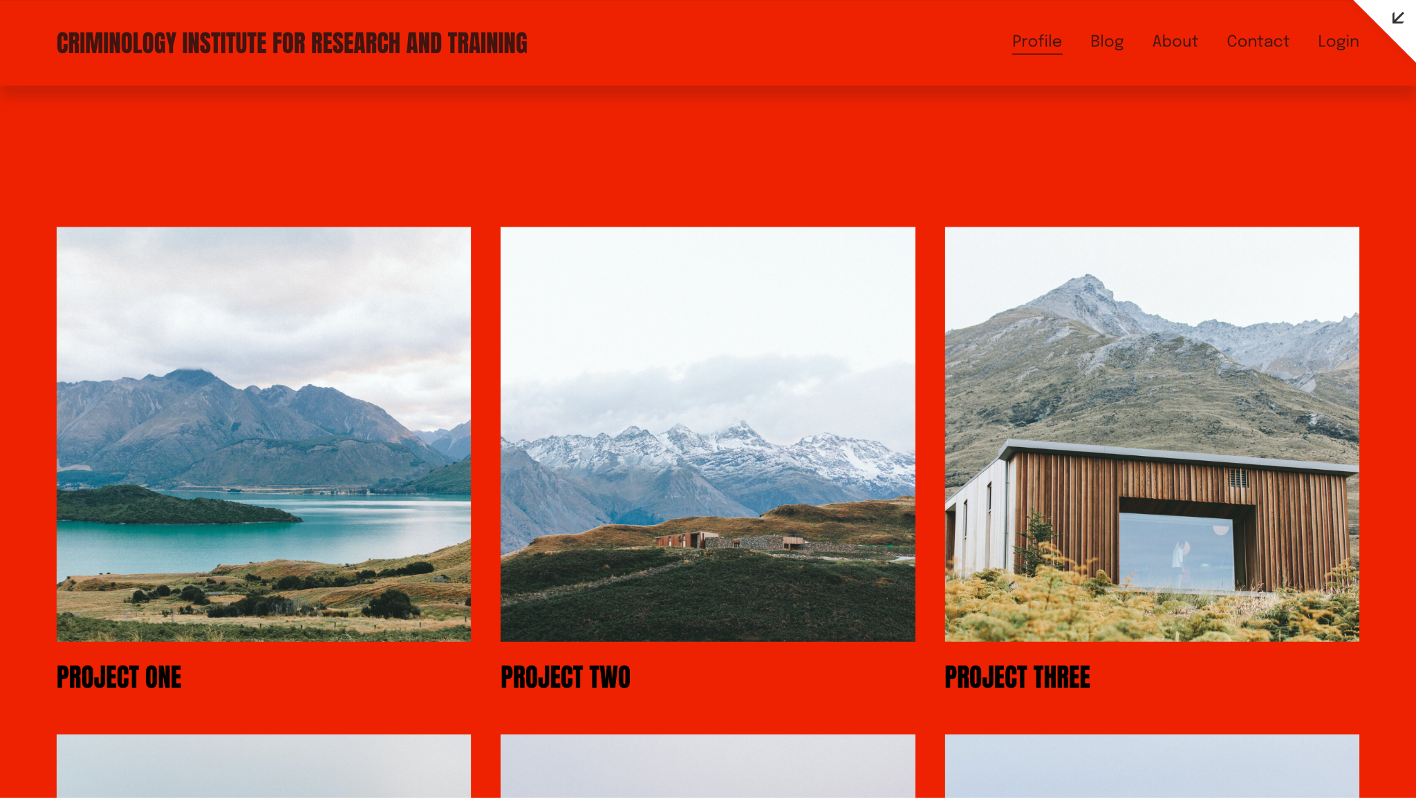

## The login prompt:



## The About prompt:



## Scroll down for a meet the team:



## The contact prompt:



## The blog prompt:

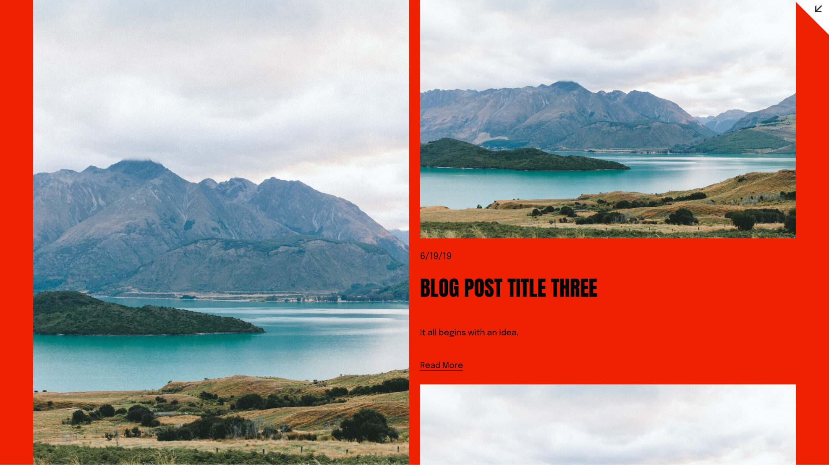

## Layout of posters/articles:

**Jaidan-**